Onboarding list for new employee ___________________
This list is a starting point to help you organize a new employee's onboarding. Please note that requirements vary by state and location, and additional legal paperwork may be required.

To be included as an attachment to the offer letter (not mandatory):
[ ] Current Playbook if your office has one
[ ] Employee handbook

Paperwork to be filled out by employee:
[ ] Direct deposit and information form from your payroll company
[ ] I9 Form (this is a link to the form expiring in May 2027)
[ ] W4 Form (this is a link to the 2026 form)

Admin:
[ ] Suggestion – Open an employee folder in Teams and share with the manager, employee, and owners. This is where all employee private paperwork can be stored, including GSR notes, goals, and related materials. You can add to it now:
- Scan of employee offer letter
- Scan any legal employment forms
- Important – you may not have the CertaPro login yet, so the employee will have to be added to this team after that happens.

[ ] Ask employee for their shirt size so you can order CertaPro Logo’d clothing from the CertaPro Store
- Link to US CertaPro Store
- Link to Canadian CertaPro Store

[ ] Ask the employee their sandwich preference—You may want to collect this to add to a master lunch list, making future lunch orders easier on the person ordering lunch.
[ ] Add employee’s birthday to OA calendar

Email activation:
[ ] DO THIS EARLY Order CertaPro email by filling out the account activation sheet on CertaCentral (first page – scroll down toward bottom in dark gray)
[ ] Let TLS know new employee’s role and cell number (support@certapro.com)
Computer, software and passwords:
[ ] New computer ordered or old computer repurposed (if necessary)
[ ] Suggestion: Wipe the laptop clean and keep Windows installed (Google the following phrase “Wipe PC clean.” It is often much easier to start a computer from scratch than try to add a new employee to an old employee’s computer)
Add the following bookmarks to the computer’s browser:
- Your company’s local CertaPro website
- https://certapro.crm.dynamics.com/ (Rename the bookmark “CertaOne”)
- https://gocerta.sharepoint.com/sites/CertaCentral (Rename the bookmark “CertaCentral”)
- https://certaone-app.certapro.com/ (Rename the bookmark “Mobile Estimator”)
- Download Microsoft 365 Teams/Outlook/Word/Excel etc., onto the computer and/or iPad/Phone (from the Google Play Store)

Take Employee Photo:
[ ] Headshot taken and sent SEO vendor for editing and posting on website with their bio.
- Ask your SEO vendor to edit all Team Photos so the background is consistent (looks so much better!)
[ ] Use headshot to make Email Signature with Photo via CertaPro Portal – Marketing Central
[ ] Make a “V card” (electronic contact card) with the new employee’s contact info:
- Text it to everyone on the team to add to their phones – include name/cell/email and photo – share via text with all staff.
- This is easiest done by creating a new contact on your iPhone and then sharing it one-by-one via text with all staff.
- It’s best to add their photo to the V Card so it appears when they call; wait until after the photo is taken.
[ ] Order business Cards from the CertaPro Store (use links from page two)

CertaPro Swag:
[ ] Order clothing in employees size from Ambrush or CertaPro Store (links on page 2)
[ ] Oder CertaPro lapel pins if appropriate for days when the polo shirts are all in the wash.
Cell Phone:
[ ] First see if you have an extra phone from a former employee. If you don’t order a cell phone (consider a refurbished one from Amazon to save money).
[ ] On employee’s first day, once they set up their cell phone with their own Apple ID, text to employee’s phone all of the contact cards of all the staff and painters (this is easily done from a cell phone and needs to be texted to them one at a time – (i.e. find Sally Smith in your phone contacts and share that contact with the new employee via text).
[ ] Not mandatory: Add staff member as authorized user with your cell phone carrier in case the phone breaks, or they need tech support. This can usually be done on the carrier’s app or by asking your local rep if you have one.

Employee Credit Card:
[ ] Order an employee credit card for gas, vehicle maintenance like oil changes and repairs, and Client entertainment.
[ ] Set up of feed of credit card transactions into QuickBooks (bookkeeper can do this)

First day “WOW”
Although this is not mandatory, I love the idea of a gift bag welcoming employees on their first day.
Think about this – when did this ever happen on your first day of work?
[ ] Make welcome bag for employee and include things like:
- Handwritten note from the owner welcoming them to the office
- CertaPro swag you have laying around (conference extras etc.)
- Post it notes
- Pens
- Sharpies
- CertaPro shirts if they’re in
- Cell phone
- Etc

(Don’t overthink this – simple and welcoming!)

Insurance:
[ ] Add employee as driver on your car insurance
[ ] Send employee’s driver’s license to insurance company (you can find the license from the I9 form they filled out)
[ ] Give employee forms for health/dental/vision/life insurance if applicable

Paid Time Off – PTO:
[ ] If you track PTO, add employee to that system (many payroll companies track this for you).

The night before the employee’s first day:
[ ] Email them to tell them how excited you are to meet them
[ ] Let them know any logistics (where to park, where to get a cup of coffee)

First day:
[ ] Have welcome bag waiting on their desk or hand to them as they walk in
[ ] Collect paperwork – and scan to their Teams folder (see page 1)
[ ] Give the employee a door key or codes to get into the office
[ ] Help staff member navigate new email: http://portal.office.com
[ ] Have staff member set up their computer – instructions in onboarding program (see below)
[ ] Help staff member navigate to their 90 day onboarding plan on CertaCentral
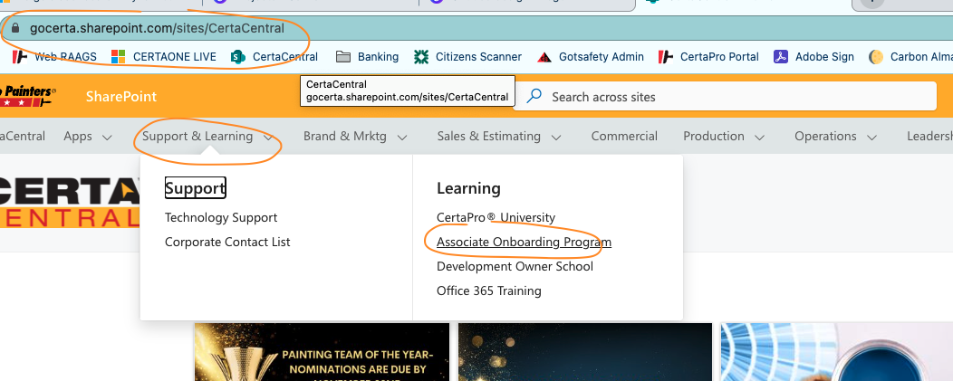

[ ] Help employee log into all apps on laptop and computer
[ ] Remind employee to set up Face or touch ID on their computer and cell (if applicable)
[ ] Remind employee to set up voicemail greeting using their name and CertaPro Painters, so clients know they’ve reached the right place.
[ ] Explain the different messaging apps & which ones you use in each situation, for example:
  - Teams: Internal staff and crew messaging
  - Outlook: Email to communicate w/customers (or forward something to a staff member)
  - Text: Personal messages only – we’ve always found it’s too hard to retrieve information at a later date

[ ] Give them the Wi-Fi password for the office

First week:
[ ] Add the employee’s GSR (Goal setting and review) weekly meetings to the manager’s calendar and share with the employee

[ ] Have your payroll company send the employee pay stub access; it's best to use their personal email when setting up access.

[ ] Employee shares Outlook calendar with Manager, OAs etc.

